Add a font
One way you can change the style of a document is by adding a new text font. To add a font to Word, download and install the font in Windows, where it will become available to all Office applications.
Fonts come as files TrueType (file extension .ttf) and OpenType (.otf).

Add a font
- Download the font files. These often come compressed in .zip folders. In one .zip folder, you might find several variations on the same font, such as “light” and “heavy.” A .zip folder usually looks like this:

- If the font files are zipped, unzip them by right-clicking the .zip folder and then clicking Extract. Now you'll see the available TrueType and OpenType font files:
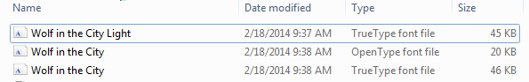
- Right-click the fonts you want, and click Install.
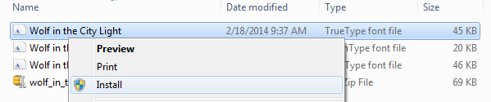
- If you're prompted to allow the program to make changes to your computer, and if you trust the source of the font, click Yes.
Your new fonts will appear in the fonts list in Word.
Here are two other ways to install and manage fonts:
- All fonts are stored in the C:\Windows\Fonts folder. You can also add fonts by simply dragging font files from the extracted files folder into this folder. Windows will automatically install them. If you want to see what a font looks like, open the Fonts folder, right-click the font file, and then click Preview.
- Another way to see your installed fonts is through Control Panel. In Windows 7 and Windows 10, go to Control Panel > Fonts. In Windows 8.1, go to Control Panel > Appearance and Personalization > Fonts.
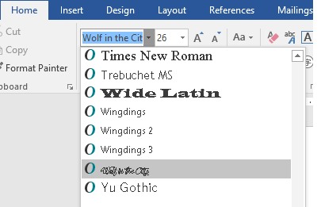
The next time you start Word, you'll see the fonts you added in the Font list.

